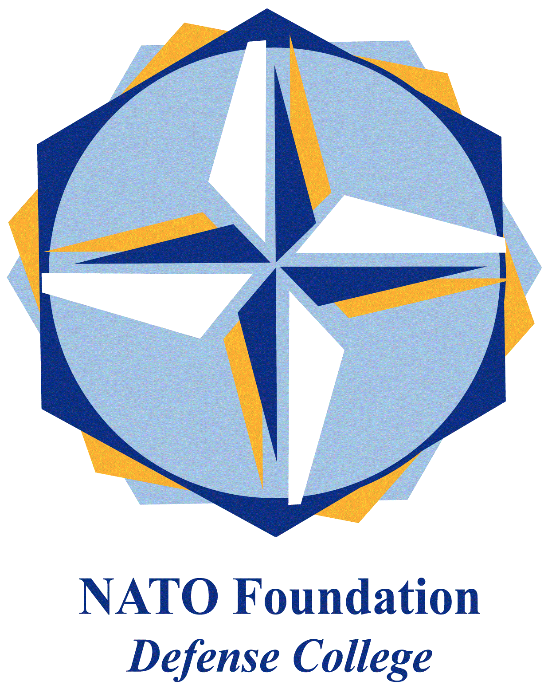
NATO DEFENSE COLLEGE FOUNDATION
STRATEGIC TRENDS
June 2015
MAGHREB
UNSMIL fourth draft rejected
In June 2015 negotiations continued between the General National Congress (GNC) in Tripoli and the House of Representative (HoR) in Tobruk. The United Nations Mission in Libya (UNSMIL) mediation was expected to provide an agreement before the start of the holy month of Ramadan on 17th June: however further obstacles emerged and disrupted the talks held successively in Algiers, Skhirat (Morocco) and Berlin.
In what the UNSMIL head Bernardino León called the ‘last and final effort for Libyan factions to reach a deal’, the fourth draft proposal met different demands advanced by the GNC. In addition to the proposal of a yearlong government of national unity with two deputies and the recognition of the HoR as Libya’s legitimate parliament, the fourth draft established the creation of a State Council: this latest organ of 120 members (90 selected from the GNC) was supposed to share the legislative power with the HoR in Libya’s institutional organization. Moreover, the draft envisaged a third chamber, the Libya dialogue, composed by the actual Libyan delegates to the UN-brokered talks and charged with the selection of the next Prime Minister.
Despite the plan was welcomed by GNC and its main political party (Justice and Construction Party, affiliated with the Muslim Brotherhood), it was rejected by the HoR in first instance on 9th of June and definitively on 12th. The outcome certified a pendulum-like dynamic of dialogue: after the rejections of a draft agreement by one faction (for example the GNC in May), the needed adjustments usually dissatisfy the other coalition (for example the HoR in June), leading to further refuses. Moreover, León proposals of a third chamber adds more confusion to an institutional architecture already complex.
For all these reasons, it could be interesting to highlight the most recent proposals originated in the east of the country, where on 3rd June a meeting hosted by Barasa tribe demanded the reinstitution of the 1951 constitution as the simplest way to resolve the crisis. The idea of a monarchy under the leadership of a Senussi relative is gaining ground not only for the obvious historical and ideological reasons, but also for more deep implications: the 1951 Constitution provided for a federal Libya with conspicuous autonomies for the three regions of Tripolitania, Cyrenaica and Fezzan. In spite of the current UN proposals representing a top-down approach, these demands could reverse the flow with a bottom-up scheme that will meet the traditional requests of the people and tribes of Libya’s regions.

Morocco towards the 2016 general elections
In Morocco, political developments are strictly associated with the race for the next legislative elections expected in 2016. On 15th May the Council of Ministers approved a revised version of the political parties law, allowing party unions to participate in the election on joint lists. This revision was demanded by the Democratic Left Federation (DLF), formed in 2014 by the United Socialist Party (PSU), the Democratic Socialist Vanguard Party (PADS) and the National Ittihadi Congress (CNI).
These three political party aspire to a parliamentary monarchy system, to social justice and to a democratic secular state. CNI was the only party in DLF which participated in the 2011 national elections, while PSU and PADS boycotted the consultations, sharing their position with the Democratic Way party: not part of the DLF, the Democratic Way is the most extremist political formation on the far left front and remains firm in its stance to boycott the next elections.
Despite the actual irrelevance of DLF (in 2007 CNI, PSU and PADS gained three seats in total), the amendment approved by the government aims at a more inclusive political representation in the next Parliament. The associate risk is a cooptation policy that will give political representation to minor parties in return for support for the government.
In effect, the ruling Parti de la justice et du développement (PJD) is struggling to contain the losses of the last months. In addition to the return of the Istiqlal to the opposition front in 2013 (rejoining the Union socialiste des forces populaire, the Parti Authenticité et Modernité and the Union Constitutionelle) the resignation of four Ministers in May 2015 (two of them representing the Amazigh’s Popular Movement) seems to indicate furthers difficulties for the PJD. This events could potentially invert the previous trend of the first months of the year, when polls showed that the Prime Minister Abdelilah Beninkrane and its government were still popular among the Moroccan people.

